H.T No
Regulations:
A20

Sreenidhi Institute of Science and Technology
(An Autonomous Institution)
Code No: 8K301 Date: 06-Feb-2025 (FN)

B.Tech II-Year I- Semester External Examination, Jan/Feb-2025 (Supplementary)
SOLID MECHANICS (CIVIL)

Time: 3 Hours Max.Marks:70

Note: a) No additional answer sheets will be provided.
b) All sub-parts of a question must be answered at one place only, otherwise it will not be valued.
c) Missing data can be assumed suitably.
Bloom's Cognitive Levels of Learning (BCLL)

Remember | L1 | Apply | L3 | Evaluate | L5
Understand | L2 | Analyze | L4 | Create | L6

Part - A Max.Marks:20

Answer all QUESTIONS.

 |  | BCLL | CO(s) | Marks
1 | Define the following properties of engineering materials:  (i) Poisson's ratio (ii) Strength | L2 | CO1 | [2M]
2 | Define shear force and bending moment. | L2 | CO2 | [2M]
3 | Define neutral axis. | L2 | CO3 | [2M]
4 | State Mohr’s theorems for finding slope and deflection of beams. | L2 | CO4 | [2M]
5 | Define the term ‘obliquity’ and how is it determined. | L2 | CO5 | [2M]
6 | Sketch the typical shear stress distribution for “T” section? | L2 | CO6 | [2M]
7 | Draw bending moment diagram for a simply supported beam of length L with an anti-clockwise moment M applied at the mid-span. | L2 | CO2 | [2M]
8 | Define the terms: bending stress in a beam, neutral axis. | L1 | CO4 | [2M]
9 | Explain Principle stress theory | L2 | CO6 | [2M]
10 | Differentiate between a fixed beam and a cantilever. | L2 | CO1 | [2M]

Part – B Max.Marks:50
ANSWER ANY FIVE QUESTIONS. EACH QUESTION CARRIES 10 MARKS.

 |  |  | BCLL | CO(s) | Marks
11. |  | A member ABCD is subjected to point loads P1, P2, P3 and P4 as shown in figure below. Calculate the force P3 necessary for equilibrium, if P1 = 45kN, P2 = 450kN and P4 = 130kN. Determine the total elongation of the member, assuming the modulus of elasticity to be 2.1x10⁵ N/mm².  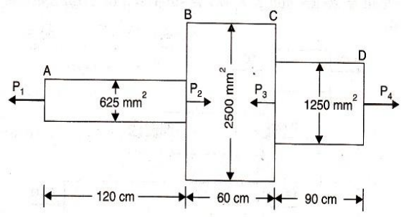 | L3 | CO1 | [10M]
12. |  | Draw the shear force and bending moment diagram for the simply supported beam shown in the figure.  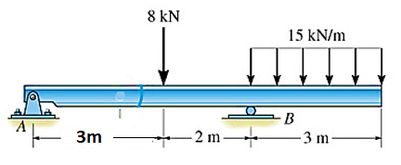 | L3 | CO2 | [10M]
13. |  | Find the moment of inertia of the section shown in Fig. below about the centroidal axis X-X perpendicularto the web.  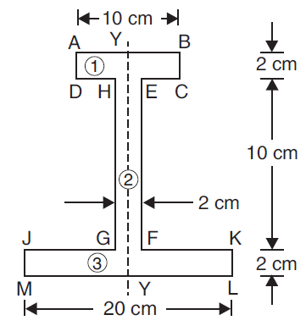 | L4 | CO3 | [10M]
14. |  | Determine the slope at both the supports and maximum deflection using Macaulay’s method. Take E = 2.1 x 10⁵ N/mm² and I = 8 x 10⁸ mm⁴.  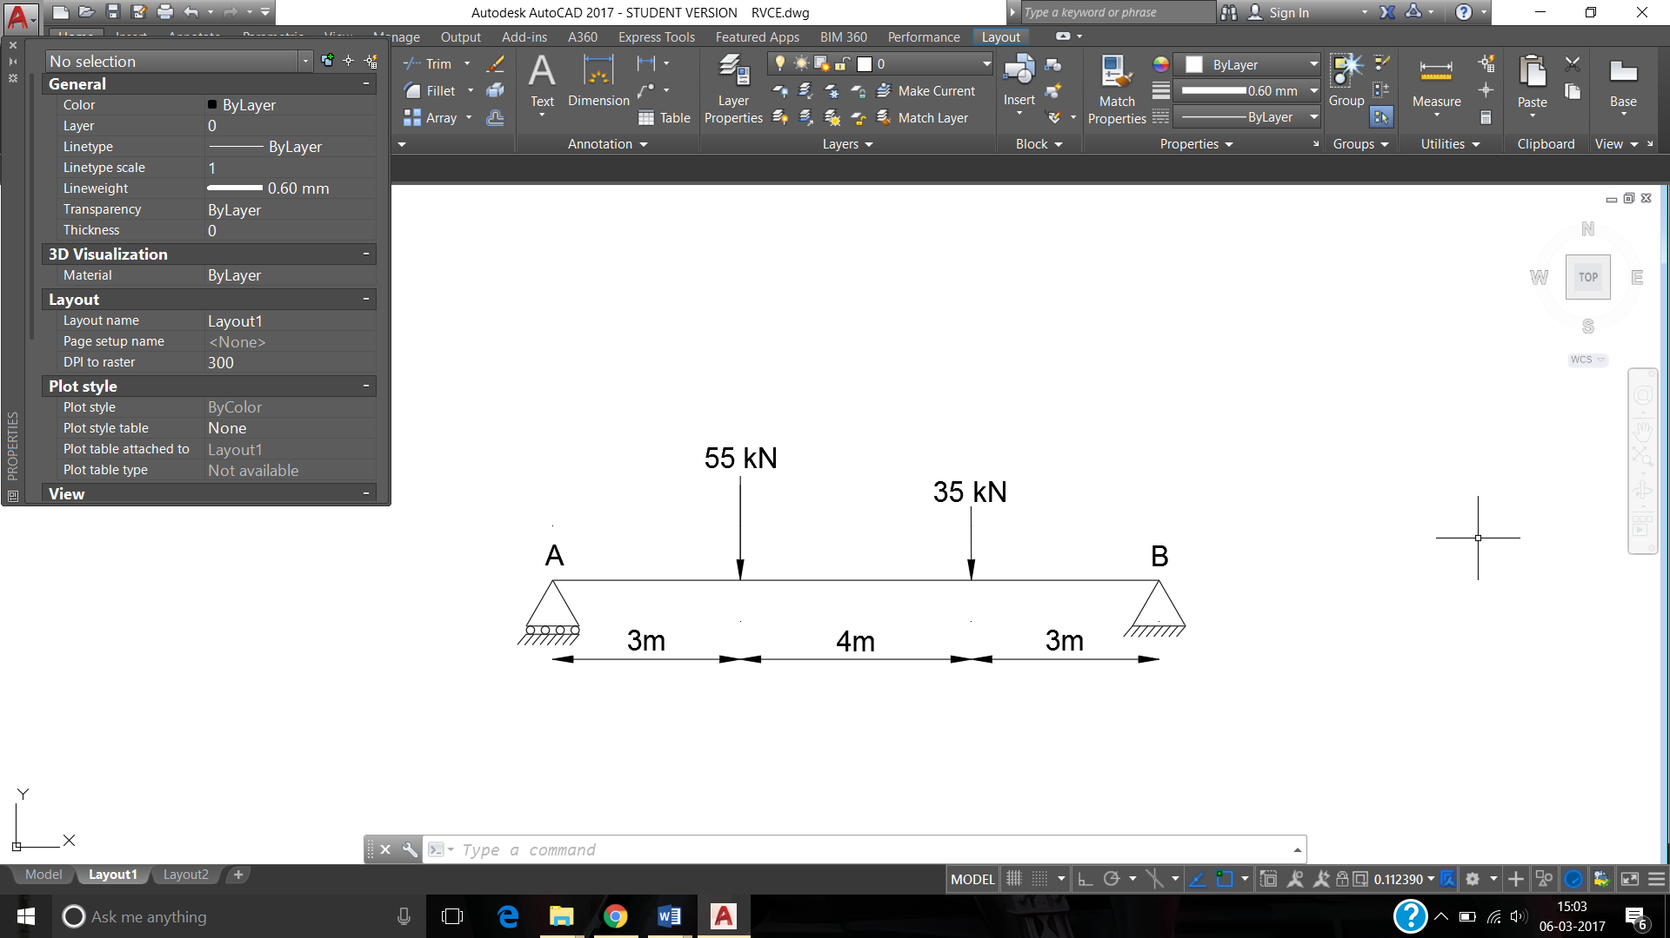 | L4 | CO4 | [10M]
15. |  | At a point in a strained material, the principal stresses are 100 N/mm² tensile and 40 N/mm² compressive. Determine the resultant stress in magnitude and direction on a plane inclined at 60° to the axis of the major principal stress. What is the maximum intensity of shear stress in the material at the point ? | L3 | CO5 | [10M]
16. |  | Discuss in detail various Theories of failure and give the application of each of them. | L4 | CO6 | [10M]
17. | a) | Determine the Poisson’s ratio and bulk modulus of a material, for which Young’s modulus is 1.2x10⁵ N/mm² and modulus of rigidity is 4.5x10⁴ N/mm² | L3 | CO1 | [5M]
 | b) | Draw shear force diagrams for a cantilever of length L carrying a point load W at the free end. | L2 | CO2 | [5M]
18. | a) | Determine the maximum deflection of a simply supported beam having length ‘l’ and point load W at the center using double integration method | L3 | CO4 | [5M]
 | b) | A wooden beam 100 mm wide and 150 mm deep is simply supported overa span of 4 metres. If shear force at a section of the beam is 4500 N, find the shear stress at a distance of 25 mm above the N.A.  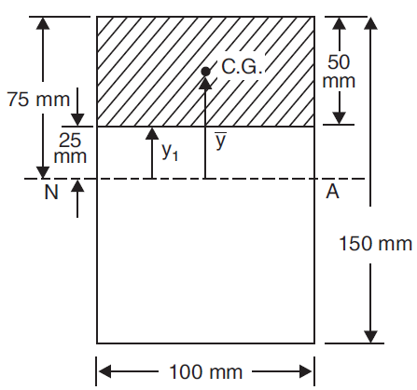 | L3 | CO6 | [5M]
-- 00 -- 00 –

